Report of Project – Comfort Furniture

1.Page of our Website - Login Page :-
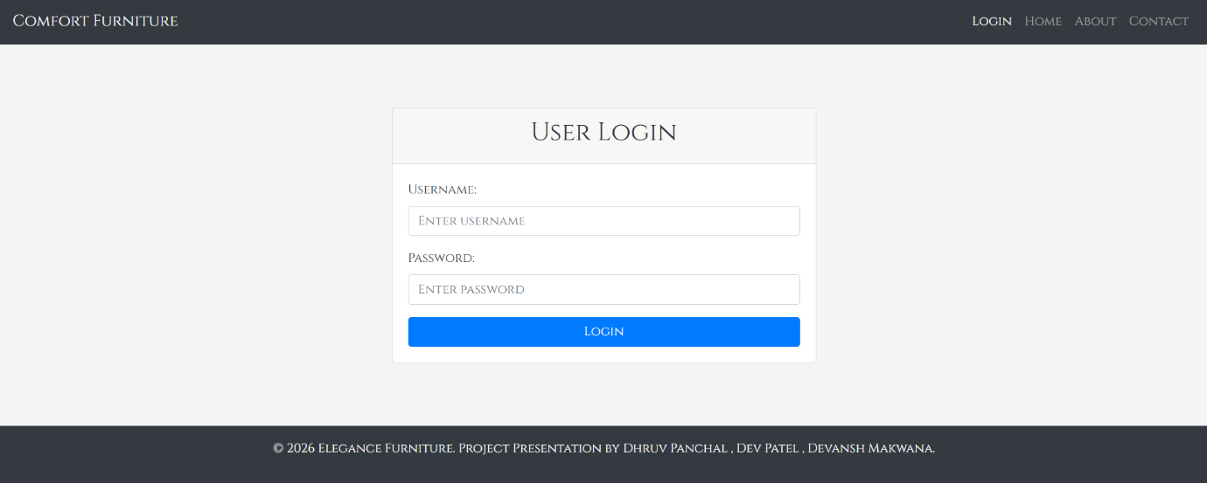
This page provides existing users with a login interface. Navigation is minimal: Login, Home, About, Contact. The main panel is labeled “User Login” with two fields: Username and Password (both have placeholder text: “ENTER USERNAME” / “ENTER PASSWORD”). A single “LOGIN” button authenticates credentials. Footer contains the same project attribution.
Key Elements:
- Two input fields (username, password)
- Login button
- No registration link shown here (separate registration exists)

2.Home Page:-

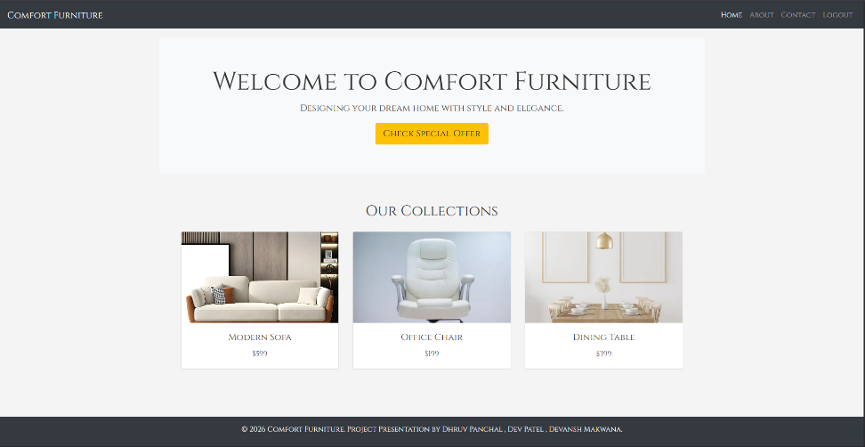

This appears to be the main landing page after a user logs in. The top navigation bar includes Home, About, Contact, Logout (confirming an authenticated session). A prominent hero section welcomes the user with the message “WELCOME TO COMFORT FURNITURE” and a tagline: “DESIGNING YOUR DREAM HOME WITH STYLE AND ELEGANCE.” A call-to-action button labeled “CHECK SPECIAL OFFER” encourages engagement. Below, an “OUR COLLECTIONS” section displays three products: Modern Sofa ($599), Office Chair ($199), and Dining Table ($399), each with image placeholders or simple text labels. The footer repeats the project credit information.
Key Elements:
- Logged-in navigation (includes Logout)
- Hero welcome message + tagline
- CTA button (“CHECK SPECIAL OFFER”)
- Three product listings with names and prices
- Footer with team attribution

3.Registration Page

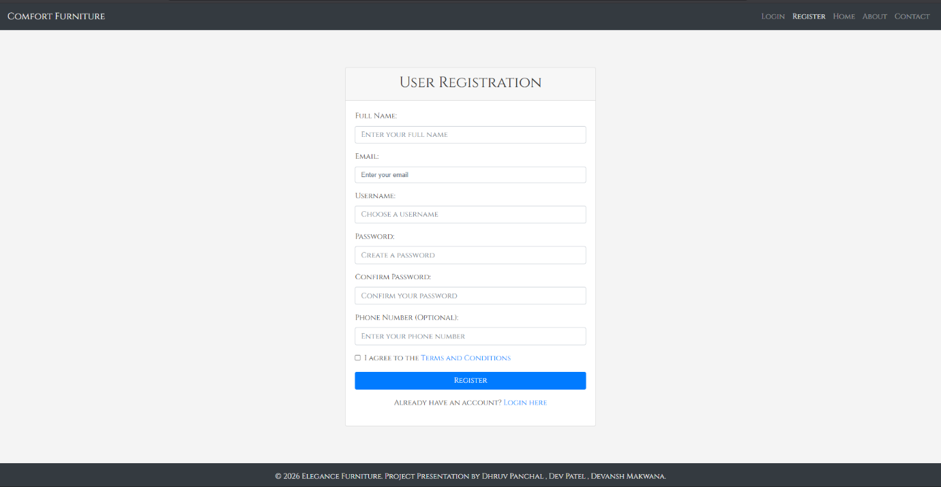

This page allows new users to create an account. Navigation includes Login, Register, Home, About, Contact. The form collects: Full Name, Email, Username, Password, Confirm Password, and optional Phone Number. A checkbox for “I AGREE TO THE TERMS AND CONDITIONS” is present. A “REGISTER” button submits the form, and a text link (“ALREADY HAVE AN ACCOUNT? LOGIN HERE”) redirects to the login page.
Key Elements:
- Six input fields (one optional)
- Terms & conditions checkbox
- Register button + login redirect link

4.Contact Page:-

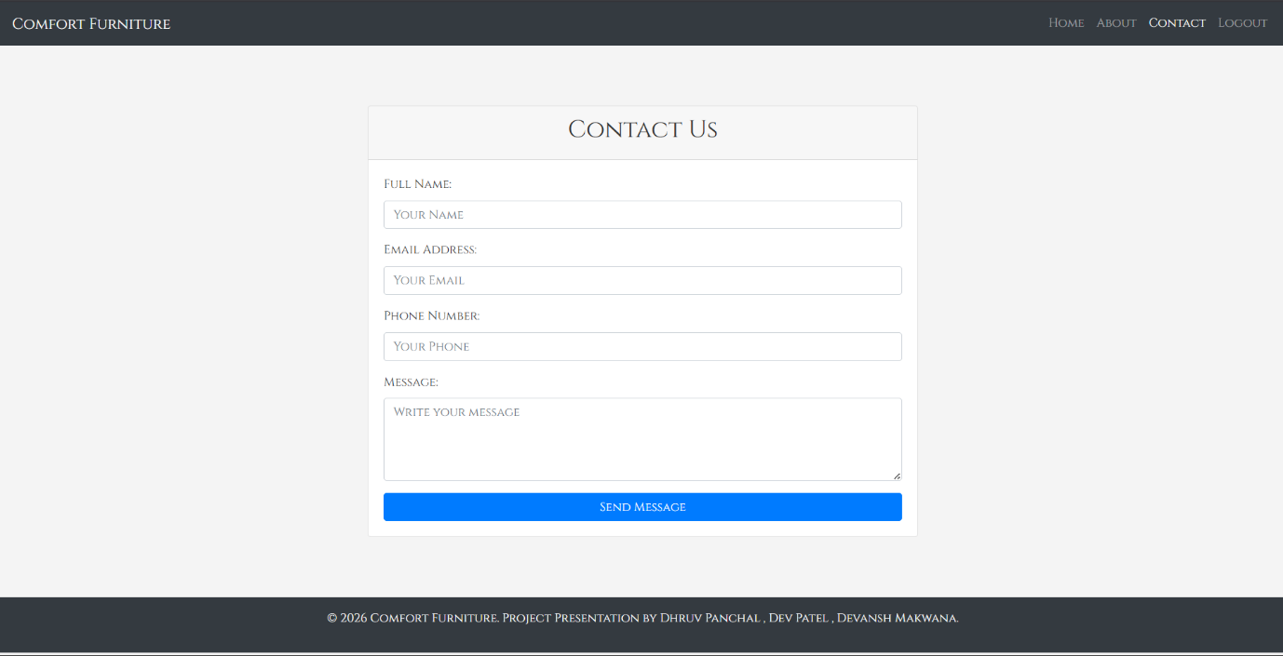

This page allows users to send messages to the company. Navigation includes Home, About, Contact, Logout (indicating a logged-in session). The contact form contains four fields: Full Name, Email Address, Phone Number, and Message (with placeholder hints). A “Send Message” button submits the inquiry. Footer repeats project credit information.
Key Elements:
- Four-field contact form
- Submit button
- Logged-in state in navigation

5.About Us Page:-

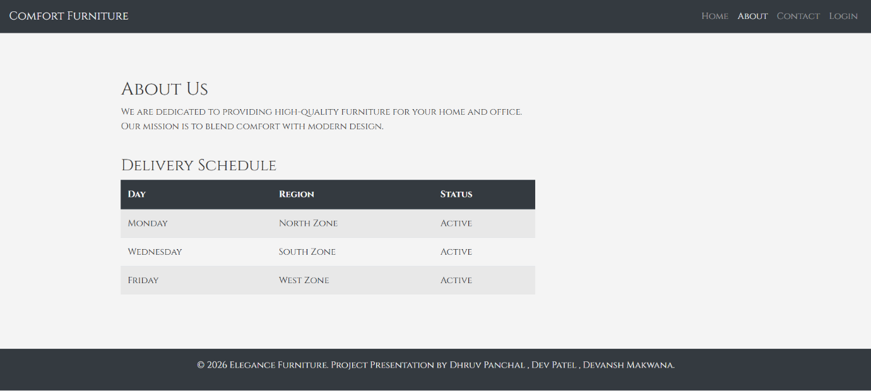

This page communicates the company’s core values and operational logistics. The top navigation bar includes Home, About, Contact, Login. The main section features an “About Us” statement emphasizing high-quality furniture and a mission to blend comfort with modern design. Below that, a “Delivery Schedule” table lists delivery days (Monday, Wednesday, Friday), regions (North, South, West Zones), and their status (all “Active”). The footer credits the project team.
Key Elements:
- Brand mission statement
- Delivery schedule table
- Footer with copyright and team names

6.Menu Bar Responsive Mobile Design:
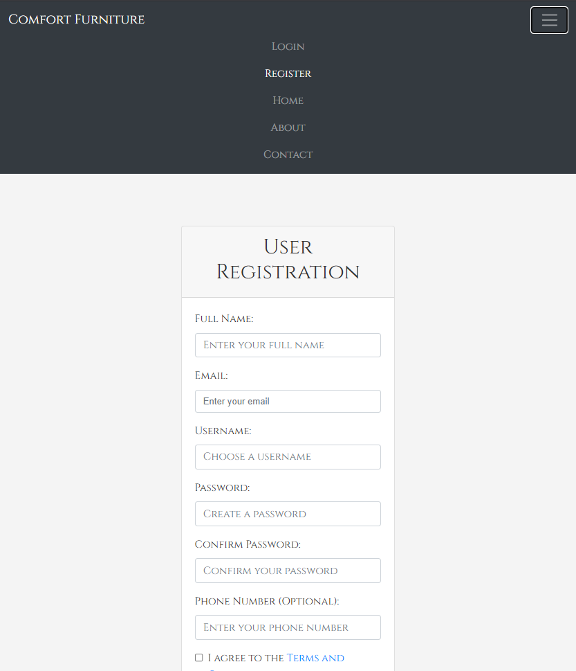
This appears to be a wireframe or simplified view showing how the registration form adapts to smaller screens or alternative layouts. It retains the same registration fields (Full Name, Email, Username, Password, Confirm Password, Phone Number) but presents them in a stacked, vertically compressed format. The top navigation is reduced to text links (LOGIN, REGISTER, HOME, ABOUT, CONTACT). The checkbox text is truncated (“I AGREE TO THE TERMS AND…”), indicating space constraints typical of responsive breakpoints.
Key Elements:
- Vertically stacked form fields
- Truncated terms text Simplified header navigation

